**MANUSCRIPT DRAFT**

**COMPARISON OF STRUCTURAL AND METABOLIC BIOMARKERS OF NEURODEGENERATION FOR BRAIN AGE PREDICTION USING MACHINE LEARNING**

E. Doering1,2, G. Antonopoulos3, M. Hönig1,4, T. van Eimeren1,2, S. Eickhoff3,5, K. Patil5, A. Drzezga1,2,4

1University Hospital Cologne, Clinic and Policlinic for Nuclear Medicine, Köln, Germany, 2German Center for Neurodegenerative Diseases, Positron Emission Tomography, Bonn, Germany, 3Forschungszentrum Jülich, Brain and Behavior (INM-7), Jülich, Germany, 4Forschungszentrum Jülich, Molecular Organization of the Brain (INM-2), Jülich, Germany, 5Heinrich-Heine-University, Institute of Systems Neuroscience, Düsseldorf, Germany

Keywords: biological age, machine learning, Alzheimer’s disease

**Journal: Nature Aging**

**Abstract**

XXX (will do this at the end)

Main text – up to 4,500 words, excluding abstract, Methods, references and figure legends.

Abstract – up to 150 words, unreferenced.

Display items – up to 8 items (figures and/or tables).

Article should be divided as follows:

Introduction (without heading)

Results

Discussion

Online Methods. ​

Results and online Methods should be divided by topical subheadings.

References – as a guideline, we typically recommend up to 60.

Articles include received/accepted dates.

Articles may be accompanied by supplementary information.

Articles are peer reviewed.

Clinical and public health research Articles may have longer abstracts to accommodate statistical information and must include a paragraph on limitations in the Discussion section.

**1 Introduction**

As the human brain ages, it undergoes various changes at all levels, from metabolism to morphology. These changes can be modeled via machine learning algorithms, learning to predict a person’s chronological age from her neuroimaging data, i.e., her ‘brain age’. Abnormal brain age, i.e. brain-predicted age difference (chronological age – brain age, “BPAD”), can serve as a single marker of general brain health1 and it has been linked to a variety of diseases, such as Schizophrenia2,3, diabetes4, Parkinson’s disease5, and mild cognitive impairment (MCI) or Alzheimer’s disease (AD)3. AD is characterized by two neuropathological hallmarks, namely the accumulation of amyloid plaques and tau tangles. Abnormal amyloid deposition has been reported to precede symptom onset by decades6 and the first anti-amyloid drugs have now gotten approved by the FDA (ADUCANUMAB REF). This makes early detection of pathological abnormality pivotal. While BPAD has been associated with general diagnoses across the AD continuum, to what extent BPAD can be used as a marker of AD neuropathology and risk of cognitive decline at early disease stages remains insufficiently understood.

Brain age prediction is most commonly achieved using structural MRI data (sMRI). SMRI depicts anatomical changes of the brain, such as atrophy, which is commonly observed in AD. sMRI represents one of two neuroimaging biomarkers of neurodegeneration in AD, the other one being 18F-Fluorodeoxyglucose-PET (FDG-PET), which unravels the molecular changes in cerebral cell metabolism. In comparison, changes in cerebral metabolism have been shown to precede volumetric loss in the course of AD and regional signal decline by age differs between the two modalities7. Therefore, FDG-PET possibly yields previously unexplored associations of BPAD and pathological/clinical AD severity especially at earlier stages of the disease. Surprisingly, the potential of FDG-PET to predict brain age has not yet been compared to the standard of sMRI. Furthermore, a stage-dependent choice of modality for brain age prediction has been completely neglected in the existing literature.

Here, we tackled the above mentioned gaps by investigating FDG-PET and sMRI-based brain age prediction using a cohort of 426 cognitively normal individuals (CN) from the Alzheimer’s Disease Neuroimaging Initiative (ADNI) and OASIS database, and 513 MCI patients from ADNI. In this study, we formulated four aims: (1) To compare the precision of brain-predicted age using FDG-PET or MRI in CN, and to differentiate the associations of BPAD with (2) cognitive performance, (3) AD neuropathology, and (4) cognitive decline in both modalities in CN and MCI.

**2 Results**

**2.1 Participants**

This study included 880 FDG-PET and MRI scans (respectively) from the Alzheimer’s Disease Neuroimaging Initiative (ADNI) database (“CN” and “MCI” samples, adni.loni.usc.edu) and 59 from the Open Acces of Imaging Studies-3 database (OASIS-3). Scans from the ADNI were selected such that FDG-PET and MRI scans from the same individual were not more than one year apart. Data was split into three samples: the “main” ADNI sample of CN individuals (“CN”, n = 367) was used to train models and yield predictions for later association of BPAD with cognitive performance, neuropathology and cognitive decline in CN. The small sample of CN derived from the OASIS-3 (“CN_validation”, n = 59) was used to validate prediction accuracy (mean absolute error, MAE) in an external dataset. Finally, predictions for the ADNI sample of MCI patients (“MCI”) were used to associate BPAD with cognitive performance, neuropathology and cognitive decline in MCI. All individuals included in this study were 65 years or older, while OASIS participants were significantly younger than ADNI participants (p < .01), especially in the MRI cohort. Compared to CN, participants in the MCI sample had a significantly lower percentage of females (χ2 = 1.5, p < .01), lower MMSE (t(424)=5.38, p < .001) and a higher percentage of amyloid positivity (χ2 = 43.7, p < .001).

|  |  |  |  |  |
| --- | --- | --- | --- | --- |
| **Table 1.** Overview of samples | | | | |
|  | CN | CN_validation | MCI |
| *n* total | 367 | 59 | 513 |
| Age [avg. years (SD)] | 74.2 (5.68) (PET)  74.2 (5.67) (MRI) | 71.7 (4.15) (PET)/  7.4 (4.17) (MRI) | 74.9 (5.77) |
| Sex [%female] | 51 | 59 | 40 |
| CSFAβ1-42 Status  (-/+/NA) | 171/111/85 | NA | 121/270/122 |
| MMSE [avg. score] | 29 (1.24) | 29 (.85) | 28 (1.77) |
| Education [avg. years (SD)] | 16 (2.72) | 16 (2.70) | 16 (2.70) |

**2.2 Precision of brain-predicted age**

To compare the potential of FDG-PET SUVR and GMV to predict chronological age, we used a nested five-fold cross-validation approach, yielding one test prediction for (almost) every subject in the ADNI CN sample, and five test predictions for each subject in the CN_validation and MCI sample. Two types of models previously recommended for small sample sizes8 were implemented for brain age prediction: support vector regression (SVR) and relevance vector regression (RVR). SVR models outperformed RVR models in each fold of the outer-loop cross-validation in both modalities. Regional FDG-PET- and MRI-predicted chronological age comparably well (Table 2) with a mean absolute error (MAE) of 1.99 and 1.89 years, respectively. In the ADNI-derived CN test sets, individuals’ brain-predicted age as assessed with FDG-PET and MRI was on average .10 and .05 years younger than their chronological age, respectively, thus demonstrating high average potential to capture brain aging in a CN cohort. The OASIS-derived CN_validation sample was used to validate our findings in an external dataset and showed similar MAEs as the ADNI sample, although chronological age was slightly better predicted from FDG-PET as compared to MRI, reflected in a lower MAE across the five models (see Table 2). A probable explanation for the higher MAE in the CN_validation MRI sample is that the age distribution in this sample deviated more from the age distribution in the ADNI train sets compared to CN_validation PET samples. In the MCI test sets, individuals’ brain-predicted age as assessed with FDG-PET and MRI was on average .77 and 1.57 years older than their chronological age, respectively, thus reflecting an advanced brain age. The bias elimination procedure successfully eliminated the correlation between chronological age and BPAD in the CN test set. For the CN_validation and MCI sample, bias elimination was successful in 3/5 CN_validation FDG-PET and all CN_validation MRI sets, while bias in MCI sets was only eliminated in 1/5 sets for both FDG-PET and MRI.

|  |  |  |  |  |  |  |  |
| --- | --- | --- | --- | --- | --- | --- | --- |
| **Table 2.** Precision of predicting chronological age from FDG-PET and MRI scans. For CN_validation and MCI, results of the first model and metrics over all five models are shown. | | | | | | | |
|  | CN | | CN_validation | | MCI | | |
|  | FDG | MRI | FDG | MRI | FDG | MRI | |
| *n* total | 345⁺ | 345⁺ | 59 | 59 | 513 | | 513 | |
| MAE | 1.99 | 1.89 | 1.83 | 2.43 | 1.96 | | 2.68 | |
| MAE before bias correction | 4.04 | 3.97 |  |  |  | |  | |
| Mean (SD) over 5 models | - | - | 2.04 (.30) | 2.45 (.19) | 2.18 (.43) | | 2.50 (.12) | |
| Mean difference | -.10 | -.05 | -.80 | -.80 | .78 | | 1.75 | |
| Mean (SD) over 5 models | - | - | -.66 (.41) | -.92 (.16) | .77 (.26) | | 1.57 (.16) | |
| *Notes.* +After outlier exclusion using CN train set (IQR > 6) | | | | | | | |

Three out of five, and five out of five optimal models were support vector machines with linear kernels. To assess brain regions important for the prediction of chronological age, we extracted the mean weight coefficients of these models. For non-linear kernels, weight coefficients are not available. Within modalities, regional weight coefficients were strongly correlated (FDG-PET: [0.80, 0.83], MRI: r = [0.87, 0.90]). Mean weight coefficients of brain regions important for this regression task were not correlated between the two modalities (r(214) = 0.045, p = 0.483), i.e. the regions used for brain age prediction in the two modalities were substantially different (see **Fig 1**).

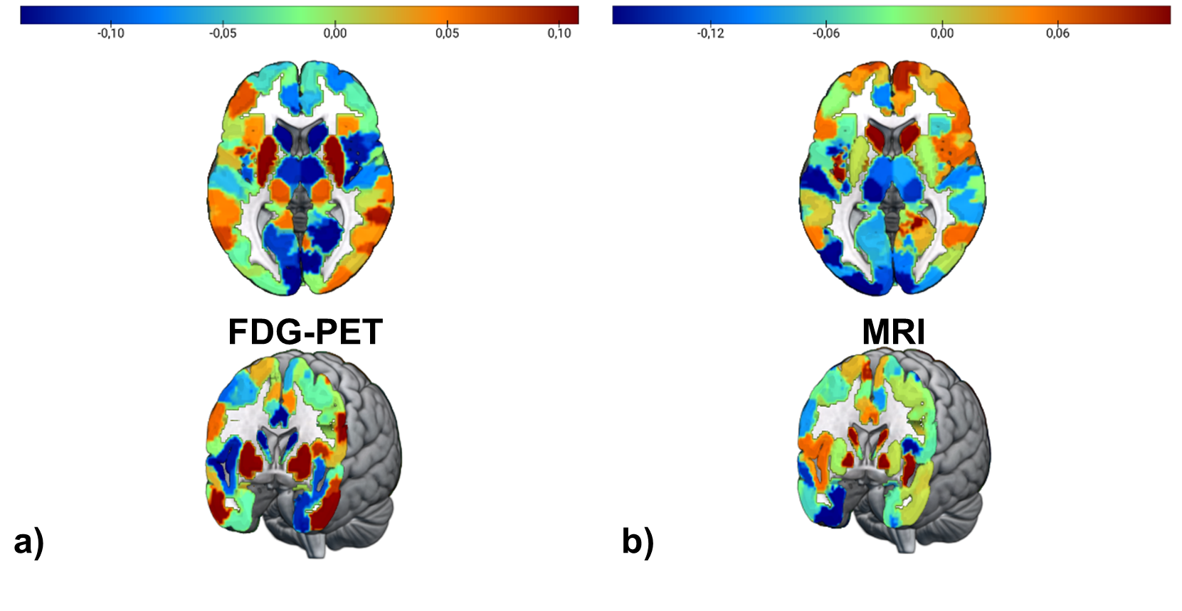

**Fig 1** **Feature importance for brain age prediction.** a) Average weights of support vector regression across three linear SVR for brain age prediction using FDG-PET. Weights were highly correlated across models (r > 0.8). b) Average weights of support vector regression across five linear SVR for brain age prediction using MRI. Weights were highly correlated across models (r > 0.8).

**2.3 BPAD and Cognitive Performance**

Partial spearman correlations between cross-sectional BPAD and memory (ADNI-MEM) and executive function scores (ADNI-EF) were calculated to evaluate whether BPAD is associated with cognitive performance in the two modalities. Age and sex were used as covariates. To adjust for multiple comparison, threshold levels of significance were adjusted by Bonferroni correction (p = .025). In CN (n = 345), there was no significant partial correlation between BPAD and ADNI-MEM in either modality when controlling for age and sex. A weak, negative, partial correlation was detected between MRI-BPAD and ADNI-EF (*ρ*(341)=-.150, *p* = .005).

In MCI (n = 512), significant, negative partial correlations between BPAD and ADNI-MEM, as well as between BPAD and ADNI-EF existed with BPAD derived from either FDG-PET or MRI and from each of the five models (Table 3). Across models, median correlation coefficients were significantly stronger between MRI-BPAD and ADNI-MEM (*z* = 3.56, *p* < .001) compared to FDG-BPAD.

**2.4 BPAD and AD Neuropathology**

Partial spearman correlations were calculated between cross-sectional BPAD and PET amyloid status (global AV45), CSF β-amyloid1–42 (CSF ABETA), CSF total-tau (CSF Tau) and CSF phospho-tau181 (CSF pTau) to evaluate whether BPAD is associated with AD neuropathology in the two modalities. Age and sex were used as covariates. To adjust for multiple comparison, threshold levels of significance were adjusted by Bonferroni correction (p = .0125). In CN (n = 266), a weak, negative, partial correlations existed between FDG-BPAD and CSF ABETA (*ρ*(262)= -.160, *p* = .009), controlling for age and sex (**Fig. 2** a)). MRI-BPAD was also partially correlated with CSF ABETA (*ρ(262)* = -.126, *p* = .040), however this correlation did not withstand Bonferroni correction. Other neuropathological measures were not associated with BPAD in CN.

In MCI (n = 392), partial correlations between BPAD and AD neuropathology revealed that FDG-BPAD was only marginally correlated with measures of amyloid across models, not always passing correction multiple comparison (CSF ABETA: p < .05; global AV45: p = .018 - .070). MRI-BPAD was more significantly correlated with measures of amyloid (CSF ABETA: p < .001; global AV45: p < .001). Moreover, partial correlations were observed between MRI-BPAD and (p-)tau, which, however, did not withstand multiple comparison adjustment in the predictions of two (total tau) and one (phospho-tau) model(s) (CSF Tau: p = .006 - .046; pTau: p = .004 – .025). Table 3 presents an overview of partial correlation coefficients which were significant at p = .05 across models.

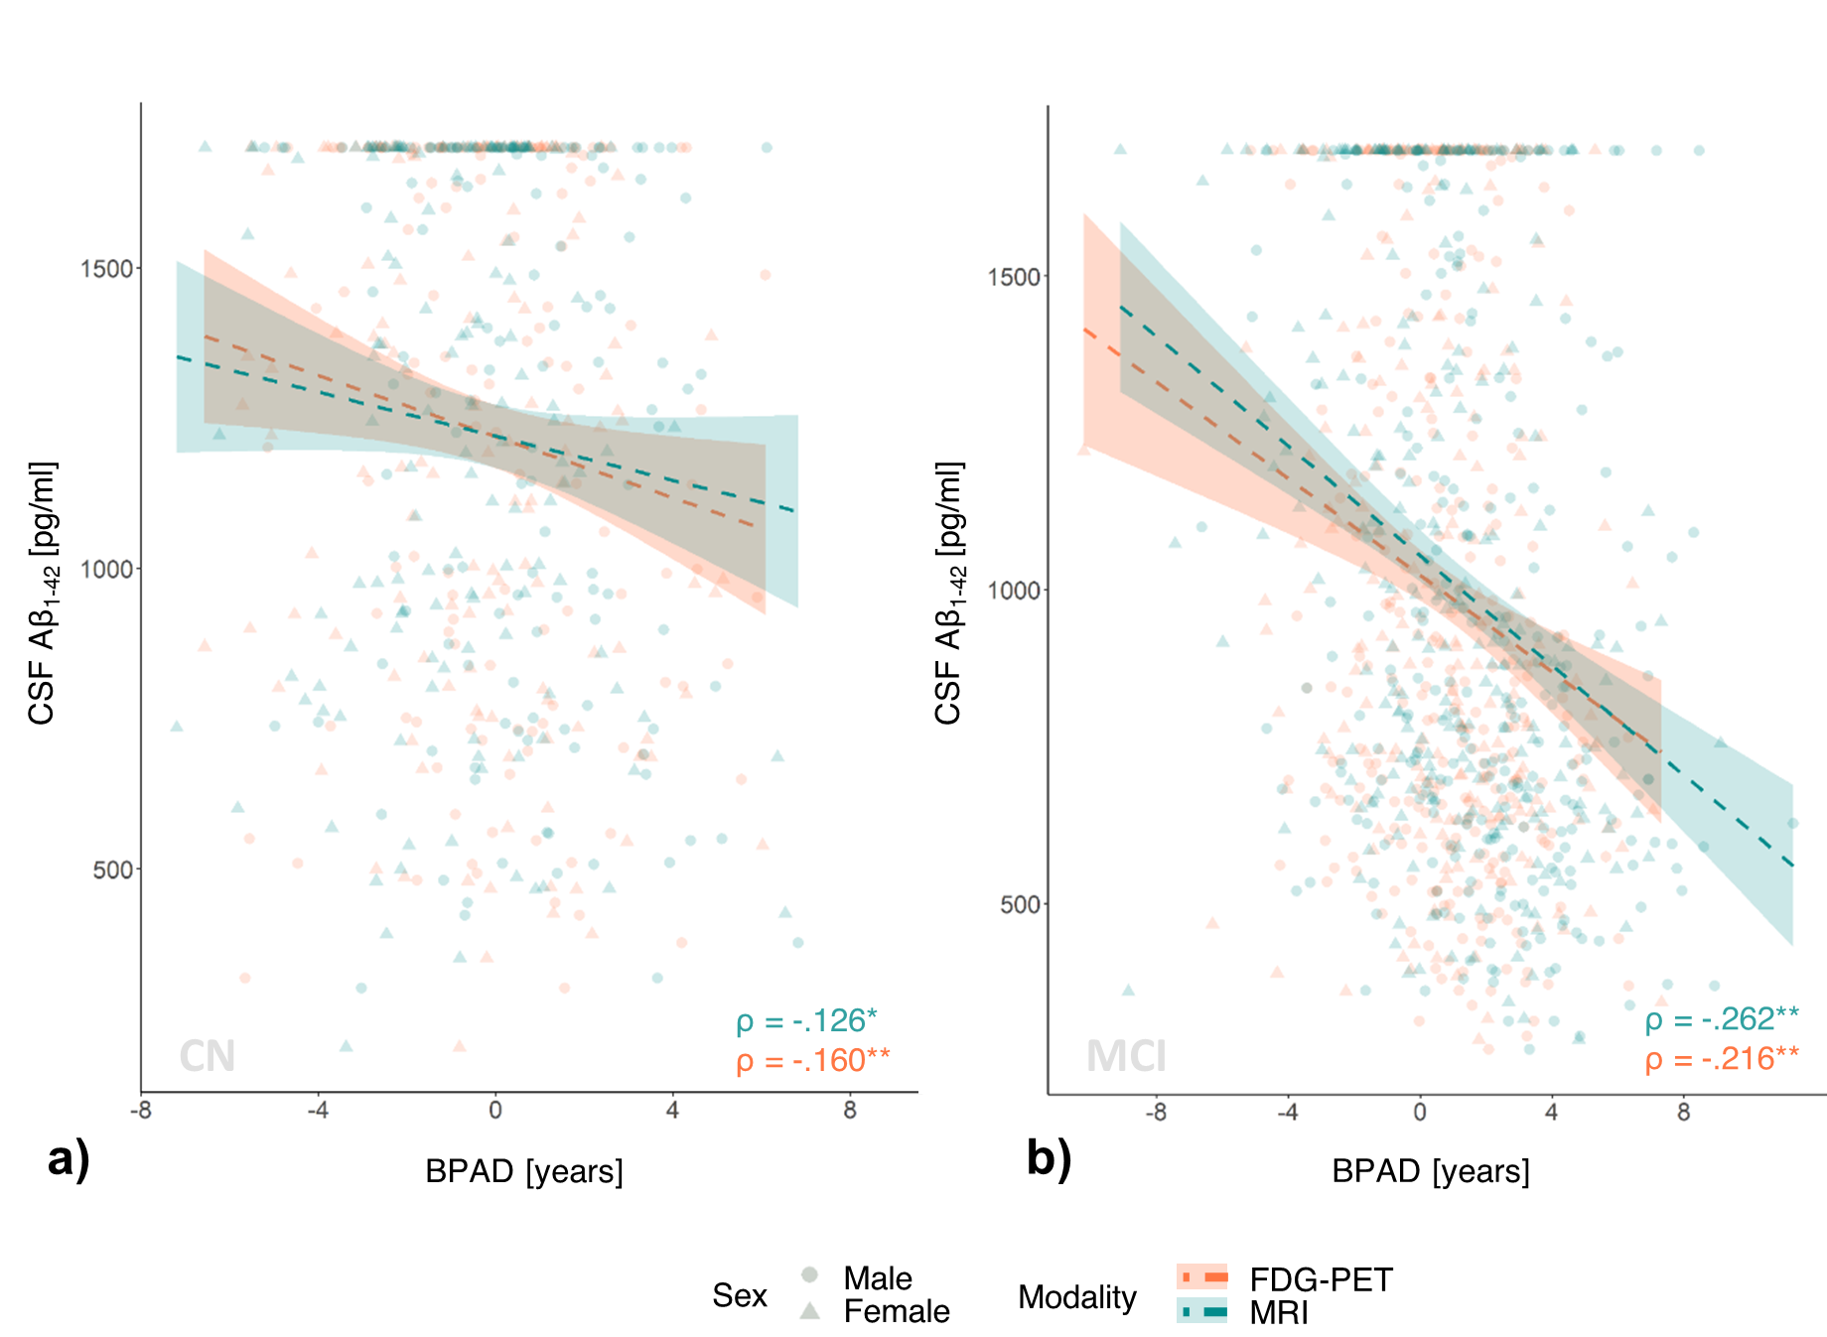

**Fig. 2 Cross-sectional correlation of BPAD and CSF Aβ1-42 in CN and MCI.** a) CSF Aβ1-42 was more significantly reduced in individuals with high FDG-BPAD compared to MRI-BPAD in CN. b) In MCI, MRI-BPAD correlated significantly stronger with CSF Aβ1-42 compared to FDG-BPAD. 1700 pg/ml represents the detection threshold of the Elecsysassay for Aβ1-42used here. * p < 0.05, ** p < 0.05 (corrected)

|  |  |  |  |  |
| --- | --- | --- | --- | --- |
| Table 3. Correlation strength between BPAD and neuropathology/cognitive function across five different models | | | | |
|  | FDG-PET | | MRI | |
|  | Zero-order | Partial | Zero-order | Partial |
| CSF ABETA | -.184  [-.215, -.150] | -.174  [-.216, -.120] | -.290  [-.294, .283] | -.262  [-.264, -.258] |
| Global AV45 | .121  [.112, .138] | ns | .204  [.189, .225] | .196  [.183, .205] |
| CSF Tau | ns | ns | .113  [.092, .123] | .128  [.101, .138] |
| CSF pTau | ns | ns | .126  [.107, .135] | .137  [.113, .145] |
| ADNI-MEM | -.236 [-.243; -.207] | -.208  [-.224; -.196] | -.437  [-.442; -.422] | -.409  [-.419; -.392] |
| ADNI-EF | -.237 [-.272; -.231] | -.224  [-.246; -.203] | -.300  [-.339; -.307] | -.290  [-.301; -.286] |
| *Notes.* Median [range] of Spearman correlation coefficients are displayed when significant (p<.05) correlation existed in brain-predicted age according to all five models. Coefficients are Spearman Rho unless marked by an asterisk. | | | | |

**2.5 BPAD and Cognitive Decline**

To assess the potential of BPAD in the two modalities to serve as an indicator of cognitive decline (CD), as well as to compare BPAD to existing risk factors, individuals’ diagnosis at year two was predicted from PET-BPAD, MRI-BPAD, APOE-e4 carriership, amyloid status and years of education. Here, we performed 10-fold cross-validated logistic regression in two subsamples per group (CN/MCI), each containing all individuals who show cognitive decline within two years, and an exclusive matched sample of non-decliners (matched in number by age and sex). As amyloid status was not available for all individuals, analyses were conducted two-fold: once including individuals with missing amyloid information (NA values coded as separate category and amyloid negativity coded as reference; “whole samples”), and once excluding these individuals (“reduced samples”).

Table 4 presents an overview of logistic regression estimates and p-values on the whole samples. Two hundred ninety eight individuals from the baseline CN sample received either a CN diagnosis at year two (“stables”; n = 269), or a diagnosis of cognitive impairment (MCI or AD) six months to two years after baseline (“decliners”; n = 29). Across the two matched sub-samples, PET- and MRI-BPAD were not significantly correlated. In sample 1, the odds of CD were increased by 40% per one year PET-BPAD (OR = 1.404, 95% CI [1.113, 1.874]). In sample 2, PET-BPAD (OR = 1.298, 96% CI [1.013, 1.734]) and amyloid status (OR = 5.011, 95% CI [1.197, 25.363]) marginally to significantly predicted CD, however, predictions in sample 2 were predominantly driven by amyloid status (see *Fig. 1* b)). To determine a clinically relevant threshold of BPAD, we approximated the PET-BPAD corresponding to 50% disease probability, which was .2 and .9 years in samples 1 and 2, respectively (*Fig. 1*). Sensitivity and specificity for prediction of CD at this threshold were 68% and 68% in sample 1 and 62% and 66% in sample 2. After removing those individuals who did not have information on amyloid status available, a reduced sample of 23 decliners remained, thus constituting a sample size of 46. In these reduced samples, higher PET-BPAD significantly predicted CD in sample 1 (OR = 1.46, 95% CI [1.101, 2.106], p = .018), whereas a positive amyloid status significantly predicted CD (OR = 4.704, 95% CI [1.135, 23.604], p = .041) in sample 2. 50% disease probability in sample 1 corresponded to a PET-BPAD of 0 years, yielding a sensitivity and specificity of 65 and 74%.

|  |  |  |  |  |
| --- | --- | --- | --- | --- |
| Table 4 Estimates (p-values) of logistic regression for prediction of cognitive decline. | | | | |
|  | CN | | MCI | |
|  | Sample  (n = 58) | Sample 2  (n = 58) | Sample 1  (n = 200) | Sample 2  (n = 200) |
| PET-BPAD [Years] | .340 (.008) | .261 (.052) | .132 (.122) | .172 (.040) |
| MRI-BPAD [Years] | .037 (.784) | .032 (.769) | .362 (<.0001) | .320 (<.0001) |
| Aβ+ | .026 (.973) | 1.612 (.036) | 1.407 (.009) | .603 (.292) |
| APOE-ε4+ | 1.464 (.104) | -.066 (.923) | .775 (.046) | 1.466 (<.001) |
| Education [Years] | -.136 (.221) | -.060 (.571) | -.031 (.646) | -.087 (.213) |

In the whole samples of MCI, 393 individuals either maintained an MCI diagnosis until year two (“stables”; n = 293) or received a diagnosis of AD six months to two years after baseline (“decliners”; n = 100). Here, we present the logistic regression results using brain age predictions from the first of five models. Results from models two to five can be found in the Supplementary materials and are highly concordant with the results presented here. Across the two matched sub-samples, PET- and MRI-BPAD were moderately strongly correlated (r­sample1 = .439; psample1 < .0001; rsample2 = .372; psample2 < .0001). In both samples, higher MRI-BPAD very significantly predicted CD (sample 1: OR = 1.436, 95% CI [1.241, 1.688]; sample 2: OR = 1.377, 95% CI [1.202, 1.599]) together with APOE-e4 carriership (sample 1: OR = XX; sample 2: OR = XX), while a positive amyloid status and higher PET-BPAD predicted CD in only one sample. Notably, MRI-BPAD showed considerably higher significance compared to other risk factors (see Table 3). Odds ratios and confidence intervals of both samples are available in Supplementary Fig. 5. Based on these two samples, a clinically relevant MRI-BPAD threshold was between 2.3 (sample 1) and 2.7 years (sample 2, see *Fig. 5* a) and b)). Reducing the input feature set of the logistic regression to only MRI-BPAD and APOE- ε4 carriership for the prediction of conversion to AD yielded AUCs (Sensitivity (SEN), Specificity (SPE)) of 81% (76%, 70%) for sample 1 and 78% (70%, 69%) for sample 2, respectively. Fig. 5 c) and d) show a reduced MRI-BPAD threshold for APOE-ε4 carriers (sample 1: 1.0 year; sample two: .3 years) compared to APOE-ε4 non-carriers (sample one: 3.6 years; sample two: 5.2 years) in this model.

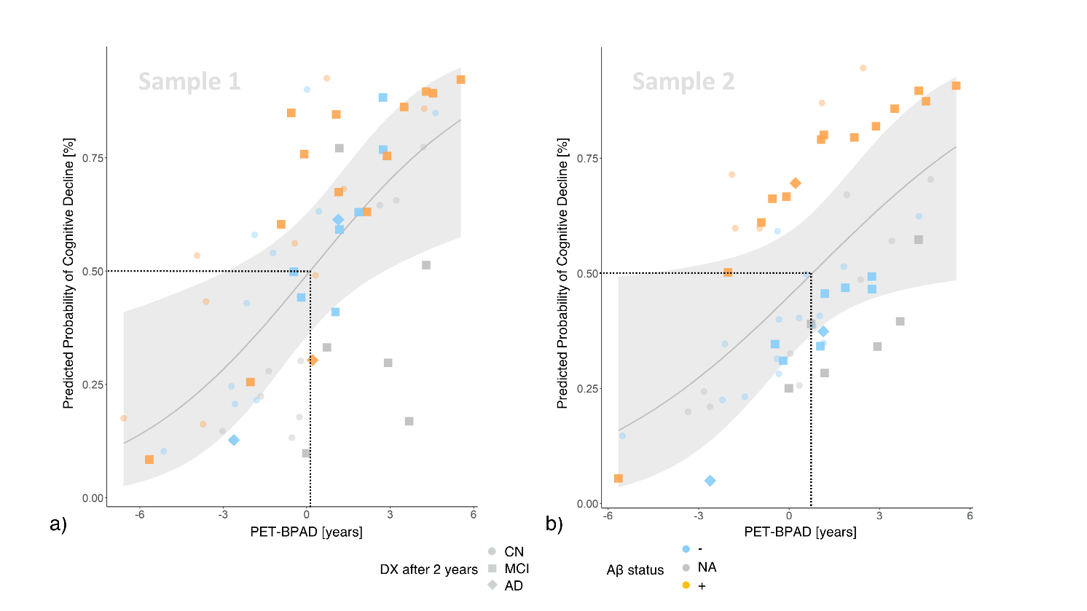

**Fig. 4 Cross-validated probability of CD within two years after a baseline diagnosis of CN by PET-BPAD.** PET-BPAD predicted CD within two years with variable control groups in the whole samples (displayed here) and in one reduced sample. Stable individuals made transparent for visibility. a) Higher PET-BPAD was the only predictor of CD in sample one. The PET-BPAD-derived threshold for CD in sample 1 (50% probability of CD; dotted line) was .2 years. b) Higher PET-BPAD and amyloid positivity predicted CD in sample two. The PET-BPAD-derived decision boundary in sample 2 was .9 years. Shaded area represents standard error. CD = cognitive decline; DX = diagnosis.

86 MCI patients had full information on all considered variables, thus constituting the decliner group of the reduced samples. Results in the reduced samples compared well to those found in the whole samples. PET- and MRI-BPAD were significantly associated with each other (r­sample1 = .390; psample1 < .0001; rsample2 = .385; psample2 < .0001). Again, MRI-BPAD (ORsample1 = 1.43, 95% CI [1.221, 1.709], p < .0001; ORsample2 = 1.36, 95% CI [1.169, 1.613], p< .001) and APOE-e4 carriership (ORsample1 = 4.088, 95% CI [1.804, 1.9.580], p < .001; ORsample2 = 5.276, 95% CI [2.435, 11.989], p< .0001) were highly significant predictors of CD. PET-BPAD, in this reduced sample, was not predictive of CD, while a positive amyloid status predicted CD in sample one. 50% probability of CD corresponded to approximately 2.1 and 2.5 years in samples one and two. Reducing the input feature set of the logistic regression to only MRI-BPAD and APOE- ε4 carriership for the prediction of conversion to AD yielded AUCs (SEN, SPE) of 81% (75%, 72%) for sample 1 and 78% (70%, 71%) for sample 2, respectively. Again, MRI-BPAD thresholds were reduced for APOE-ε4 carriers (sample 1: -.1 year; sample two: -.2 years) and increased for APOE-ε4 non-carriers (sample one: 4.1 years; sample two: 5.1 years).

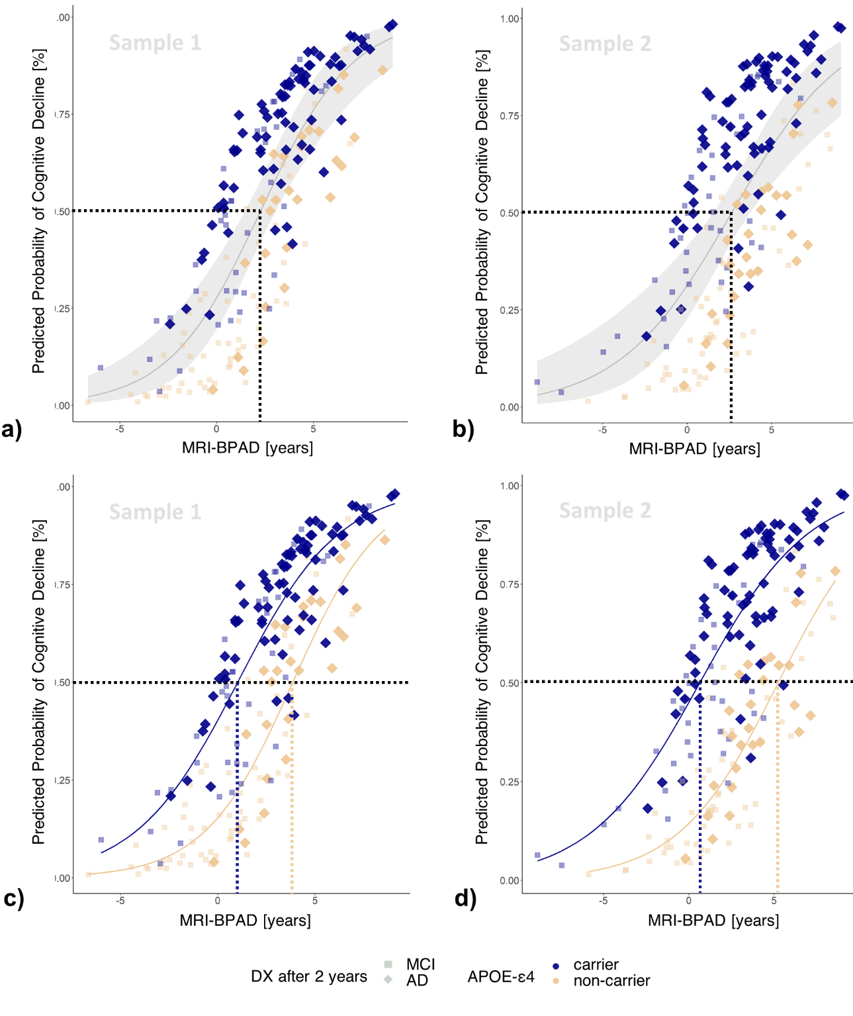**Fig. 5 Cross-validated probability of cognitive decline within two years after a baseline diagnosis of MCI by MRI-BPAD.** Higher MRI-BPAD and a positive amyloid status, together with higher XX PET-BPAD and a positive APOE-ε4 carriership predicted CD within two years with variable control groups. Stable individuals made transparent for visibility. a) The MRI-BPAD-derived threshold for CD in sample 1 (50% probability of disease progression; dotted line) was 2.1 years. b) The MRI-BPAD-derived decision boundary in sample 2 was 2.2 years. Shaded area represents standard error. c) and d) 50% probability of cognitive decline requires a lower MRI-BPAD in APOE-e4 carriers compared to carriers. CD = cognitive decline; DX = diagnosis.

Finally, due to the correlation observed between PET- and MRI-BPAD in the MCI sample, we additionally assessed logistic regression models with unimodal BPAD9. Considered in separate models, both MRI- and PET-BPAD very significantly predicted (Supplementary Table XX) CD together with APOE-e4 carriership and amyloid status (p < .01 in all whole and reduced samples). However, MRI-BPAD continued to show higher significance compared to PET-BPAD.

**Discussion**

The existing literature on brain age mainly defined brain age as chronological age predicted from MRI scans. Here, we have shown that FDG-PET predicts brain age as well as MRI, and FDG-BPAD can serve as a marker of AD severity where MRI-BPAD falls short. Precisely, we demonstrated that FDG-BPAD is superior in representing AD neuropathology and risk of cognitive decline in CN. MRI-BPAD, on the other hand, was more closely associated with a decline of executive function within the range of a CN diagnosis, as well as memory function, AD neuropathology and cognitive decline in MCI.

Our findings are in favor of a time line in which FDG-PET brain age better captures early disease-related neuropathology and risk, while the later onset of tau-related neurodegeneration and of objective cognitive decline are more strongly associated with signals of increasing brain age on MRI. This is in line previous work delineating that FDG-PET shows greater and more consistent changes early in the AD continuum, whereas MRI is superior in delineating AD-related changes with an AD diagnosis7. The current results expand on this finding by showing that MRI superiority is already present at the MCI stage. In clinical practice, the general brain health of CN could be assessed with FDG-PET-derived measures of brain age. This may be especially relevant for CN experiencing subjective cognitive impairment (SCI). Persons with SCI recognize cognitive deficits before they become objectively measurable. These individuals were shown to be more likely to develop MCI or AD compared to CN without SCI10. Differences on MRI brain age between CN and SCI have previously been shown, as SCI demonstrated a brain age advanced by 1.1 years3. The same model predicted the brain age of MCI to be advanced by 1.6 years, which is very close to our current results on MRI. To establish an optimal modality for brain age assessment in SCI will be an interesting topic for future research. For MCI patients, MRI scans are already routinely done, thus the assessment of brain health in these individuals and especially their risk of cognitive decline could be assessed without further strain. XX COMPARE TO AMYLOID MEASURES WHICH ARE NOT REALLY SPECIFIC

BPAD IN CLINICAL TRIALS

* Indicator of eneral brain health
* provide indication of at-risk population (BPAD above certain thresholds)
* Maybe metabolism can be increased in trials and thus FDG-BPAD could even be used as outcome? MRI can’t, whats gone is gone

Increased BPAD was associated cross-sectionally with cognitive deficits in MCI, as well as with longitudinal cognitive decline in CN (FDG-BPAD) and MCI (MRI-BPAD). Usage of BPAD for clinical trials

The specific application of FDG-PET BPAD as a biomarker of very early cognitive deficits blabla

* Studies: early detection of cognitive deficit and pathology
* BPAD as a biomarker in clinical practice
  + To clarify etiology of MCI, MRI scans are already routinely done 🡪

CONVERSION

* MCI to AD conversion with brain age (in-sample prediction): AUC .83 in 12 months, .73 in 36 months 11
* In MCI, APOE and MRI-BPAD competed for first place to determine conversion. Combined observation of these two to assess risk of conversion has previously been suggested and is supported by our analyses (CITE GATEKEEPING PAPER)
* LIFESTYLE AND GENETIC FACTORS (here) HAVE AN INFLUENCE 4 🡪 additional consideration of lifestyle factors such as presence of diabetes, smoking or alcohol intake may significantly improve prediction of cognitive decline
* BPAD = 0 enough for APOE positive in MCI 🡪 no severe neurodegeneration in aging relevant areas 🡪 does APOE speed up pending neurodegeneration?

APOE “doomed” for cognitive decline? Non-APOE != AD?

Zusammenhang amyloid cascade & APOE, APOE & metabolismus (🡪

NEURODEGENERATION = FAST AGING?;

* Feature-importance shows aging and disease related structures, only cognitively normal individuals included 🡪 neurodegeneration = faster aging?
  + Amyloid negatives + positives in sample
* Early detection is important, disease-slowing & anti-amyloid drugs & clinical trials
* COMBINATION OF FACTORS:
* Limitations:
  + Small sample of converters with baseline CN diagnosis resulted in large standard error 🡪 pending confirmation by larger sample sizes, possibly outside of ADNI
  + FDG-PET quite expensive, will not be done in CN population without reason
  + Amyloid not predictive of conversion to AD in MCI sample 2 🡪 likely due to high collinearity of amyloid status and APOE
  + “In cases where the number of features for each data point exceeds the number of training data samples, the SVM will underperform.” 🡪 5-fold cv on 367 samples with 216 features: not enough samples 🡪 next approaches could investigate influence of feature reduction techniques on brain age prediction
  + Nfl easier accessed, but just one-dimensional 🡪 Likely, one-dimensional feature spaces such as a single plasma or cerebrospinal fluid biomarker will be insufficient
  + Amyloid positive individuals in training set 🡪 “cognitively normal” rather than “neuroscientifically healthy”, but latter definition hard to achieve due to multitude of variables to control for: decided to take representative sample of old individuals without cognitive impairment as reference group

analyses in the MCI sample revealed that both PET- and MRI-BPAD indicate conversion to AD. Notably, an MRI-BPAD greater than 2.3 years was identified as a specific and sensitive marker of CD, which outperformed other risk factors of CD in MCI in sample one in terms of significance and specificity. However, sensitivity and specificity scores are not high enough for MRI-BPAD to serve as a stand-alone biomarker of CD. Potentially, MRI-BPAD can serve as a reliable biomarker of CD together with APOE-e4 carriership, as Figure XX suggests different BPAD thresholds may apply as a function of the latter. XX

1. Cole, J. H., Marioni, R. E., Harris, S. E. & Deary, I. J. Brain age and other bodily ‘ages’: implications for neuropsychiatry. *Molecular Psychiatry* vol. 24 (2019).

2. Shahab, S. *et al.* Brain structure, cognition, and brain age in schizophrenia, bipolar disorder, and healthy controls. *Neuropsychopharmacology* **44**, (2019).

3. Rokicki, J. *et al.* Multimodal imaging improves brain age prediction and reveals distinct abnormalities in patients with psychiatric and neurological disorders. *Hum. Brain Mapp.* **42**, (2021).

4. Cole, J. H. Multimodality neuroimaging brain-age in UK biobank: relationship to biomedical, lifestyle, and cognitive factors. *Neurobiol. Aging* **92**, (2020).

5. Eickhoff, C. R. *et al.* Advanced brain ageing in Parkinson’s disease is related to disease duration and individual impairment. *Brain Commun.* **3**, (2021).

6. Jack, C. R. & Holtzman, D. M. Biomarker modeling of alzheimer’s disease. *Neuron* vol. 80 (2013).

7. Dukart, J. *et al.* Generative FDG-PET and MRI Model of Aging and Disease Progression in Alzheimer’s Disease. *PLoS Comput. Biol.* **9**, e1002987 (2013).

8. Beheshti, I. *et al.* Predicting brain age using machine learning algorithms: A comprehensive evaluation. *IEEE J. Biomed. Heal. Informatics* (2021) doi:10.1109/JBHI.2021.3083187.

9. Ranganathan, P., Pramesh, C. & Aggarwal, R. Common pitfalls in statistical analysis: Logistic regression. *Perspect. Clin. Res.* **8**, (2017).

10. Parfenov, V. A., Zakharov, V. V., Kabaeva, A. R. & Vakhnina, N. V. Subjective cognitive decline as a predictor of future cognitive decline a systematic review. *Dement. e Neuropsychol.* **14**, (2020).

11. Gaser, C., Franke, K., Klöppel, S., Koutsouleris, N. & Sauer, H. BrainAGE in Mild Cognitive Impaired Patients: Predicting the Conversion to Alzheimer’s Disease. *PLoS One* **8**, (2013).

12. LaMontagne, P. J. *et al.* OASIS-3: Longitudinal neuroimaging, clinical, and cognitive dataset for normal aging and Alzheimer disease. *medRxiv* (2019) doi:10.1101/2019.12.13.19014902.

13. Verger, A., Doyen, M., Campion, J. Y. & Guedj, E. The pons as reference region for intensity normalization in semi-quantitative analysis of brain 18FDG PET: application to metabolic changes related to ageing in conventional and digital control databases. *EJNMMI Res.* **11**, 1–7 (2021).

14. Schaefer, A. *et al.* Local-Global Parcellation of the Human Cerebral Cortex from Intrinsic Functional Connectivity MRI. *Cereb. Cortex* **28**, (2018).

15. Tian, Y., Margulies, D. S., Breakspear, M. & Zalesky, A. Hierarchical organization of the human subcortex unveiled with functional connectivity gradients. *bioRxiv* (2020) doi:10.1101/2020.01.13.903542.

16. Suzman, R. & Riley, M. W. Introducing the ‘oldest old’. *Milbank Mem. Fund Q. Health Soc.* **63**, (1985).

17. Baecker, L. *et al.* Brain age prediction: A comparison between machine learning models using region- and voxel-based morphometric data. *Hum. Brain Mapp.* **42**, (2021).

18. Pedregosa, F. *et al.* *Scikit-learn: Machine Learning in Python Gaël Varoquaux Bertrand Thirion Vincent Dubourg Alexandre Passos PEDREGOSA, VAROQUAUX, GRAMFORT ET AL. Matthieu Perrot*. *Journal of Machine Learning Research* vol. 12 http://scikit-learn.sourceforge.net. (2011).

19. Liang, H., Zhang, F. & Niu, X. Investigating systematic bias in brain age estimation with application to post-traumatic stress disorders. *Hum. Brain Mapp.* **40**, (2019).

20. de Lange, A. M. G. & Cole, J. H. Commentary: Correction procedures in brain-age prediction. *NeuroImage: Clinical* vol. 26 (2020).

21. Beheshti, I., Nugent, S., Potvin, O. & Duchesne, S. Bias-adjustment in neuroimaging-based brain age frameworks: A robust scheme. *NeuroImage Clin.* **24**, (2019).

22. Cole, J. H. *et al.* Brain age predicts mortality. *Mol. Psychiatry* **23**, (2018).

23. Hansson, O. *et al.* CSF biomarkers of Alzheimer’s disease concord with amyloid-β PET and predict clinical progression: A study of fully automated immunoassays in BioFINDER and ADNI cohorts. *Alzheimer’s Dement.* **14**, (2018).

NOTES

Cole Multimodality 2020:  “Multimodality neuroimaging can improve brain-age prediction, and derived brain-PAD values are sensitive to biomedical and lifestyle factors that negatively impact brain and cognitive health.” (modeled with structural and functional MRI) 🡪 whether some single modalities are more useful for the usage of BPAD in certain tasks is unclear

Rokicki: Age prediction based on structural MRI data shows high accuracy in common brain disorders. However, brain aging is complex and heterogenous, both in terms of individual differences and the underlying biological processes.

Rokicki: MCI the difference was 1.6 years (although smaller sample size, similar finding using MRI)

“Brain-age prediction uses machine learning to estimate an individuals apparent brain aging based on structural and functional brain characteristics derived from neuroimaging, commonly magnetic resonance imaging (MRI). Subtracting chronological age from estimated brain age provides a measure of the difference between an individuals predicted and chronological age; the *brain age delta*. For instance, if a 60 year old individual exhibits a brain age delta of -5 years, their typical aging pattern resembles the brain structure of a 55 year old, i.e., their estimated brain age is younger than what is expected for their chronological age. Individual variation in delta estimations have been associated with a range of biological and cognitive variables. brain-age estimation also involves a **frequently observed bias:** brain age is overestimated in younger subjects and underestimated in older subjects, while brain age for participants with an age closer to the mean age (of the training dataset) are predicted more accurately”

Brain-predicted age (BPA)

Chronological age (CA)

Brain-predicted age difference (BPAD)

mean absolute error (MAE)

<https://pubmed.ncbi.nlm.nih.gov/11526211/>

[https://n.neurology.org/content/65/8/1227 FOR CONVERSION JACK 2005](https://n.neurology.org/content/65/8/1227%20FOR%20CONVERSION%20JACK%202005)

DUKART 2013: The model suggests greater and more consistent changes in FDG-PET compared to sMRI at earlier and the inversion of this pattern at more advanced AD stages.

* **First paragraph: aging of the brain**
  + late-life adult brain shrinks with increasing age
  + changes at all levels from metabolism to morphology
  + incidence of stroke, white matter lesions, and dementia also rise with age
  + thus, abnormal brain age could be used as a biomarker for proneness to neurodegenerative diseases, such as Alzheimer’s disease
  + however, state-of-the-art machine learning models of normal brain aging are mostly based on structural MRI, thereby restricting brain age prediction to changes in morphology
  + young-old, middle-old, oldest-old → different risk factors associated with being of high age [Suzman 1985], but inherent resilience against age-related detrimental factors may be in place which allows reaching such high age, e.g. “Overall, there is evidence that pathological substrates of cognitive deterioration in the oldest-old are different from those observed in the younger-old. Microvascular parameters such as mean capillary diameters may be key factors to consider for the prediction of cognitive decline in the oldest-old. Neuropathological particularities of the oldest-old may be related to “longevity-enabling” genes” [von Gunten 2010]
* **Second paragraph: MRI - FDG-PET comparison**
  + FDG-PET unravels the molecular changes in cell metabolism of the brain
  + structural MRI depicts anatomical changes, such as atrophy
  + FDG-PET, as compared to MRI captures first AD-related changes earlier and more accurately [1,2,3]
  + FDG-PET displays greater and more consistent changes as compared to structural MRI at early stages of AD [3]
  + therefore, FDG-PET possibly yields previously unexplored information about brain age
* **Third paragraph: What is a good brain age model**
  + brain age = neuroimaging-predicted chronological age
  + brain-predicted age difference (BPAD) = brain age - chronological age
  + ...
* **Fourth paragraph: Aim of the study**
  + 1) to find suitable bias-correction for FDG-PET and T1-weighted MRI
  + 2) to **compare the predictive value** of FDG-PET and MRI for brain age in CN
  + 3) to assess **BPAD in individuals with MCI**
  + 4) to associate **BPAD with neuropsychology and neuropathology**

**Method**

**Participants - ADNI**

Baseline T1-weighted MRI (T1w MRI) and  18F-Fluorodesoxyglucose-PET (18F-FDG-PET) scans of 370 cognitively normal (CN) elderly (65 years+) individuals used in the preparation of this article were obtained from the Alzheimer's Disease Neuroimaging Initiative (ADNI) database ([adni.loni.usc.edu](https://ida.loni.usc.edu/collaboration/access/adni.loni.usc.edu)). The primary goal of ADNI has been to test whether serial MRI, PET, other biological markers, and clinical and neuropsychological assessment can be combined to measure the progression of MCI and AD. We required the time interval between T1w MRI and 18F-FDG-PET scans to not exceed 12 months. The ADNI dataset was split into 70% training and 30% testing set.

XX MCI XX REMOVE INDIV YOUNGER THAN 65!

**Participants - OASIS**

To test our algorithms in an external dataset, we additionally considered 60 CN elderly  participants from the Open Access of Imaging Studies-3 (OASIS-3) database (https://www.oasis-brains.org/) 12. Given the small sample size of participants who received both an sMRI and 18F-FDG-PET within 12 months, we eliminated this time constraint for the OASIS test set.

**Acquisition & Preprocessing of Biomarkers of Neurodegeneration**

XX Acquisition XX

First, T1-weighted images were preprocessed using denoising (spatial-adaptive Non-Local Means), spatial registration, bias-correction and skull-striping. Then the images are segmented by an adaptive maximum a posteriori approach (Rajapakse et al. 1997) with partial volume model (Tohka et al. 2004). For non-linear transformation, the Geodesic Shooting Algorithm (Ashburner & Friston 2011) was used based on SPM12 (v7771) using Matlab (R2017b) and compiled for containerization in Singularity (2.6.1)

18F-FDG-PET scans in both samples were acquired dynamically 30-60 minutes (6x5min frames) after injection with an average dose of 185 MBq (5mCi). Pre-processing was performed using the Statistical Parametric Mapping 12 toolbox (SPM12; [www.fil.ion.ucl.ac.uk](http://www.fil.ion.ucl.ac.uk)): First, each individual’s 18F-FDG-PET scan was averaged across frames. Second, all 18F-FDG-PET scans were aligned to the anterior commissure/posterior commissure. Third, all 18F-FDG-PET scans were co-registered and normalized to an MRI template. Lastly, standardized uptake value ratios (SUVr) were calculated (reference: pons 13).

**Calculation of brain-predicted age**

Mean gray matter volume (GMV) and SUVr were extracted for T1w MRI and 18F-FDG-PET, respectively, using a composite atlas containing 200 cortical 14 and 16 sub-cortical regions 15. Next, the ADNI data of CN individuals was split in a stratified manner into a train (70%) and a test set (30%). Through stratification, the original proportions of young-old (65 - 74 years), middle-old (75 - 84 years) and oldest-old classes (85 years+) 16 in the whole ADNI dataset were maintained in the train and test set. For data quality assurance across modalities, all 216 regions’ interquartile ranges (IQR) were calculated on the train set. Subjects from the train set, as well as the ADNI and OASIS test set, with a mean regional GMV and/or SUVr outside of three times a region’s IQR (“extreme outlier”) were excluded from both the T1w MRI and the 18F-FDG-PET dataset (n=XX).

Figure XX illustrates the procedure of brain age prediction. To estimate BPA using T1w MRI and 18F-FDG-PET, we compared relevance vector regression (RVR) and support vector regression (SVR). These machine learning models are prominently used for brain age prediction and are especially suited for training on small datasets 17. Optimal (hyper)parameters were determined using five-fold stratified cross-validation in scikit-learn 18 (for a list of hyperparameters, see Supplementary Materials Table 1). During each iteration of cross-validation, four parts of the training data were first scaled (by removing the median and scaling the data according to the IQR) and then used to fit the models. The respective scaling parameters were subsequently applied to the validation set (fifth part of training data). The fitted models were used to predict CA from either neuroimaging modality in the validation set and these predictions were stored for bias-correction. As a result of cross-validation, one optimal RVR and one optimal SVR was yielded, where “optimal” refers to the respective (hyper)parameter configuration that allowed for the smallest average MAE between CA and BPA across the validation sets.

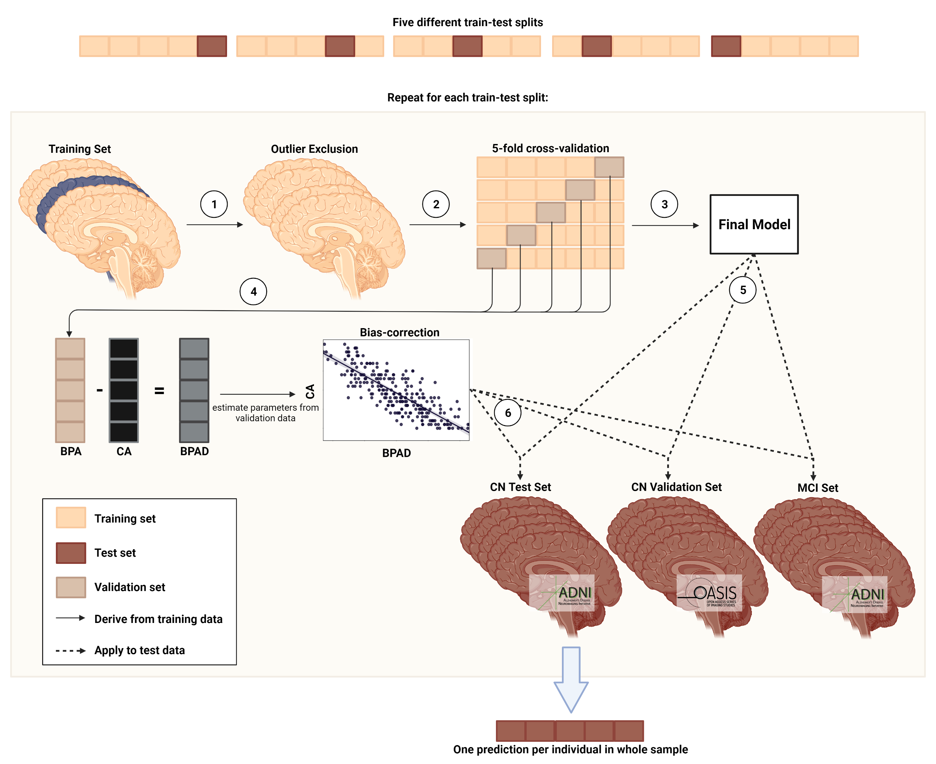

**Bias-correction**

BPA is subject to a frequently reported bias, in which BPA of older individuals is under- and BPA of younger individuals is overestimated [XX], regardless of which data or method is used 19. Several methods exist to correct for this bias, which can be broadly summarized into *methods including chronological age in the correction* and *methods not including chronological age in the correction* 20. While the first set of methods reduces the MAE and variance between CA and BPA, the latter increases it. To obtain an in-depth understanding of the effect of both methods on the prediction of CA from T1w MRI and 18F-FDG-PET, we implemented both kinds of methods and compared MAE and R² between them and uncorrected predictions, thus aiming to replicate the results from Beheshti et al. 21 with our data from two different neuroimaging modalities. Bias-correction methods were implemented using five-fold cross-validated predictions of the whole train set.

For a bias-correction procedure with CA, we used the method proposed by Beheshti and colleagues 21, where a linear regression model is fit on BPAD versus CA, yielding a slope (ɑ) and an intercept (β). Bias-free brain age is then calculated as:

$${Predicted age}_{corrected with CA}={Predicted age}_{uncorrected}-(α*CA+β)$$

The second bias-correction procedure we assessed was a bias-correction procedure without CA proposed by Cole et al. 22, which Beheshti et al. compared their proposed algorithm to. In this method, a linear regression model is fit on BPA versus CA. Without CA, bias-free brain age is then calculated as:

$${Predicted age}_{corrected without CA}=\frac{{Predicted age}_{uncorrected}-β}{α}$$**Validation of brain-predicted age results**

* **Comparison of Predictive Value of** 18F-FDG-PET and T1w MRI for Brain Age Prediction
* **Brain age prediction (feature extraction, features importance, features interaction etc)**
* **Neuropsychology/neuropathology correlations**

CSF Amyloid cut-off for positivity: 1100 pg/ml 23

**Results**

|  |  |  |  |  |
| --- | --- | --- | --- | --- |
| Table 1. Overview of samples | | | | |
|  | **CN** | **CN_validation** | **MCI** |
| ***n* total** | **367** | **59** | **621** |
| Age [avg. years (SD)] | 74.2 (5.68) | 71.7 (4.15) (PET)/  70.4 (4.17) (MRI) | 72.5 (7.52) |
| Sex (F/M) | 196/183 | 35/24 | 264/355 |
| Amyloid Status (negative/positive/NA) | XX | XX | XX |
| MMSE [avg. score] | 29 | 29 | 28 |
| Education [avg. years] | 16 | 16 | 16 |

|  |  |  |  |  |  |  |  |  |  |  |
| --- | --- | --- | --- | --- | --- | --- | --- | --- | --- | --- |
| Table 2. Precision of predicting chronological age from FDG-PET and MRI scans. For CN_validation and MCI, results of the first model and metrics over all five models are shown. | | | | | | | | | | |
|  | **CN** | | **CN_validation** | | | **MCI** | | |
|  | **FDG** | **MRI** | **FDG** | | **MRI** | **FDG** | | **MRI** | |
| ***n* total** | 345⁺ | 345⁺ | 59⁺ | | 59⁺ | 621 | | 621 | |
| **MAE** | 1.99 | 1.89 | 1.83 | | 2.42 | 1.94 | | 2.66 | |
| MAE before bias correction | 4.04 | 3.97 |  | |  |  | |  | |
| Mean (SD) over 5 models | - | - | 2.04 (0.30) | | 2.45 (0.19) | 2.17 (0.44) | | 2.57 (0.11) | |
| **Mean difference** | -0.10 | -0.05 | -0.80 | | -0.80 | 0.78 | | 1.15 | |
| Mean (SD) over 5 models | - | - | -0.66 (0.41) | | -0.92 (0.16) | 0.67 (0.21) | | 1.42 (0.16) | |
| *Notes.* *After outlier exclusion using CN train set (IQR > 6) | | | |  | | |

**Discussion**

**Conclusion**

OLD References

[1] J. Dukart, K. Mueller, H. Barthel, A. Villringer, O. Sabri, and M. L. Schroeter, “Meta-analysis based SVM classification enables accurate detection of Alzheimer’s disease across different clinical centers using FDG-PET and MRI,” *Psychiatry Res. - Neuroimaging*, vol. 212, no. 3, pp. 230–236, Jun. 2013, doi: 10.1016/j.pscychresns.2012.04.007.

[2] J. Dukart et al, “Generative FDG-PET and MRI Model of Aging and Disease Progression in Alzheimer’s Disease” Apr 2013

[3] Y. Yuan, Z. X. Gu, and W. S. Wei, “Fluorodeoxyglucose-positron-emission tomography, single-photon emission tomography, and structural MR imaging for prediction of rapid conversion to alzheimer disease in patients with mild cognitive impairment: A meta-analysis,” *Am. J. Neuroradiol.*, vol. 30, no. 2, pp. 404–410, Feb. 2009, doi: 10.3174/ajnr.A1357.

[3] Dukart, J. *et al.* Generative FDG-PET and MRI Model of Aging and Disease Progression in Alzheimer’s Disease. *PLoS Comput. Biol.* **9**, e1002987 (2013).

[5] Beheshti, I., Nugent, S., Potvin, O., & Duchesne, S. (2019). Bias-adjustment in neuroimaging-based brain age frameworks: A robust scheme. *NeuroImage. Clinical*, *24*, 102063. https://doi.org/10.1016/j.nicl.2019.102063

Verger A, Doyen M, Campion JY, Guedj E (2021) The pons as reference region for intensity normalization in semi-quantitative analysis of brain 18FDG PET: application to metabolic changes related to ageing in conventional and digital control databases. EJNMMI Res 11:1–7

LaMontagne, P. J., Benzinger, T. L. S., Morris, J. C., Keefe, S., Hornbeck, R., Xiong, C., … Marcus, D. (2019). OASIS-3: Longitudinal neuroimaging, clinical, and cognitive dataset for normal aging and Alzheimer disease. *MedRxiv*. <https://doi.org/10.1101/2019.12.13.19014902>

Alexander Schaefer, Ru Kong, Evan M Gordon, Timothy O Laumann, Xi-Nian Zuo, Avram J Holmes, Simon B Eickhoff, B T Thomas Yeo, Local-Global Parcellation of the Human Cerebral Cortex from Intrinsic Functional Connectivity MRI, *Cerebral Cortex*, Volume 28, Issue 9, September 2018, Pages 3095–3114,<https://doi.org/10.1093/cercor/bhx179>

Tian, Y., Margulies, D. S., Breakspear, M., & Zalesky, A. (2020). Hierarchical organization of the human subcortex unveiled with functional connectivity gradients. bioRxiv, 2020.01.13.903542.

Suzman R, Riley MW. Introducing the "oldest old". Milbank Mem Fund Q Health Soc. 1985 Spring;63(2):177-86. PMID: 3846808.

von Gunten A, Ebbing K, Imhof A, Giannakopoulos P, Kövari E. Brain aging in the oldest-old. *Curr Gerontol Geriatr Res*. 2010;2010:358531. doi:10.1155/2010/358531

Pedregosa, F., Varoquaux, G., Gramfort, A., Michel, V., Thirion, B., Grisel, O., … Duchesnay, É. (2011). Scikit-learn: Machine learning in Python. *Journal of Machine Learning Research*, *12*, 2825–2830.

de Lange, A. G., & Cole, J. H. (2020). Commentary: Correction procedures in brain-age prediction. *NeuroImage. Clinical*, *26*, 102229. <https://doi.org/10.1016/j.nicl.2020.102229>

Cole, J. H., Ritchie, S. J., Bastin, M. E., Valdés Hernández, M. C., Muñoz Maniega, S., Royle, N., Corley, J., Pattie, A., Harris, S. E., Zhang, Q., Wray, N. R., Redmond, P., Marioni, R. E., Starr, J. M., Cox, S. R., Wardlaw, J. M., Sharp, D. J., & Deary, I. J. (2018). Brain age predicts mortality. *Molecular psychiatry*, *23*(5), 1385–1392. https://doi.org/10.1038/mp.2017.62

1. Cole, J. H., Marioni, R. E., Harris, S. E. & Deary, I. J. Brain age and other bodily ‘ages’: implications for neuropsychiatry. *Molecular Psychiatry* vol. 24 (2019).

2. Shahab, S. *et al.* Brain structure, cognition, and brain age in schizophrenia, bipolar disorder, and healthy controls. *Neuropsychopharmacology* **44**, (2019).

3. Rokicki, J. *et al.* Multimodal imaging improves brain age prediction and reveals distinct abnormalities in patients with psychiatric and neurological disorders. *Hum. Brain Mapp.* **42**, (2021).

4. Cole, J. H. Multimodality neuroimaging brain-age in UK biobank: relationship to biomedical, lifestyle, and cognitive factors. *Neurobiol. Aging* **92**, (2020).

5. Eickhoff, C. R. *et al.* Advanced brain ageing in Parkinson’s disease is related to disease duration and individual impairment. *Brain Commun.* **3**, (2021).

6. Jack, C. R. & Holtzman, D. M. Biomarker modeling of alzheimer’s disease. *Neuron* vol. 80 (2013).

7. Dukart, J. *et al.* Generative FDG-PET and MRI Model of Aging and Disease Progression in Alzheimer’s Disease. *PLoS Comput. Biol.* **9**, e1002987 (2013).

8. Beheshti, I. *et al.* Predicting brain age using machine learning algorithms: A comprehensive evaluation. *IEEE J. Biomed. Heal. Informatics* (2021) doi:10.1109/JBHI.2021.3083187.

9. Ranganathan, P., Pramesh, C. & Aggarwal, R. Common pitfalls in statistical analysis: Logistic regression. *Perspect. Clin. Res.* **8**, (2017).

10. Parfenov, V. A., Zakharov, V. V., Kabaeva, A. R. & Vakhnina, N. V. Subjective cognitive decline as a predictor of future cognitive decline a systematic review. *Dement. e Neuropsychol.* **14**, (2020).

11. Gaser, C., Franke, K., Klöppel, S., Koutsouleris, N. & Sauer, H. BrainAGE in Mild Cognitive Impaired Patients: Predicting the Conversion to Alzheimer’s Disease. *PLoS One* **8**, (2013).

12. LaMontagne, P. J. *et al.* OASIS-3: Longitudinal neuroimaging, clinical, and cognitive dataset for normal aging and Alzheimer disease. *medRxiv* (2019) doi:10.1101/2019.12.13.19014902.

13. Verger, A., Doyen, M., Campion, J. Y. & Guedj, E. The pons as reference region for intensity normalization in semi-quantitative analysis of brain 18FDG PET: application to metabolic changes related to ageing in conventional and digital control databases. *EJNMMI Res.* **11**, 1–7 (2021).

14. Schaefer, A. *et al.* Local-Global Parcellation of the Human Cerebral Cortex from Intrinsic Functional Connectivity MRI. *Cereb. Cortex* **28**, (2018).

15. Tian, Y., Margulies, D. S., Breakspear, M. & Zalesky, A. Hierarchical organization of the human subcortex unveiled with functional connectivity gradients. *bioRxiv* (2020) doi:10.1101/2020.01.13.903542.

16. Suzman, R. & Riley, M. W. Introducing the ‘oldest old’. *Milbank Mem. Fund Q. Health Soc.* **63**, (1985).

17. Baecker, L. *et al.* Brain age prediction: A comparison between machine learning models using region- and voxel-based morphometric data. *Hum. Brain Mapp.* **42**, (2021).

18. Pedregosa, F. *et al.* *Scikit-learn: Machine Learning in Python Gaël Varoquaux Bertrand Thirion Vincent Dubourg Alexandre Passos PEDREGOSA, VAROQUAUX, GRAMFORT ET AL. Matthieu Perrot*. *Journal of Machine Learning Research* vol. 12 http://scikit-learn.sourceforge.net. (2011).

19. Liang, H., Zhang, F. & Niu, X. Investigating systematic bias in brain age estimation with application to post-traumatic stress disorders. *Hum. Brain Mapp.* **40**, (2019).

20. de Lange, A. M. G. & Cole, J. H. Commentary: Correction procedures in brain-age prediction. *NeuroImage: Clinical* vol. 26 (2020).

21. Beheshti, I., Nugent, S., Potvin, O. & Duchesne, S. Bias-adjustment in neuroimaging-based brain age frameworks: A robust scheme. *NeuroImage Clin.* **24**, (2019).

22. Cole, J. H. *et al.* Brain age predicts mortality. *Mol. Psychiatry* **23**, (2018).

23. Hansson, O. *et al.* CSF biomarkers of Alzheimer’s disease concord with amyloid-β PET and predict clinical progression: A study of fully automated immunoassays in BioFINDER and ADNI cohorts. *Alzheimer’s Dement.* **14**, (2018).